Technical Document for Exadata cellnode disk replacement

Environment :- We have 10 Exadata Machine currently in system and out of them 4 are production and 6 are non-production.

|  |  |  |  |  |
| --- | --- | --- | --- | --- |
| Sr. No. | Machine Name | Configuration | Environment | Serial Number |
| 1 | DM15 | Oracle X6-2 Rackmount | Production | AK00361891 |
| 2 | DM16 | Oracle X6-2 Rackmount | Production | AK00361896 |
| 3 | DM17 | Oracle X6-2 Rackmount | Non-Production | AK00361890 |
| 4 | DM18 | Oracle X6-2 Rackmount | Non-Production | AK00361895 |
| 5 | DM19 | Oracle X6-2 Rackmount | Non-Production | AK00361892 |
| 6 | DM20 | Oracle X6-2 Rackmount | Non-Production | AK00361897 |
| 7 | DM21 | Oracle X6-2 Rackmount | Production | AK00382636 |
| 8 | DM22 | Oracle X6-2 Rackmount | Production | AK00382635 |
| 9 | db-e901hhd | Oracle Server X8-2 Rack | Non-Production | AK00570491 |
| 10 | db-e901OEd | Oracle Server X8-2 Rack | Non-Production | 1943XLB051 |

IP/Host Name Details :-

Please find the attached IP/hostname details for all Exadata machine cell node/ILOMs and compute nodes /ILOMs .



Technical steps to identified failed disk in cellnode :-

CellCLI> list celldisk

CellCLI> list physical disk

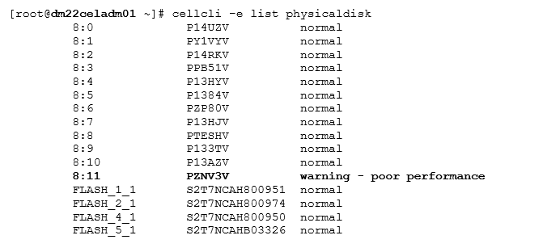

Now, raise a Oracle SR and upload TFA t the time of SR creation to get response faster from Oracle support.

In https:\\support.oracle.com

On first page of create SR , default selection is hardware . Now just put serial number (given above) and it will identify the machine automatically then put it as P1 and next upload the TFA . and submit.

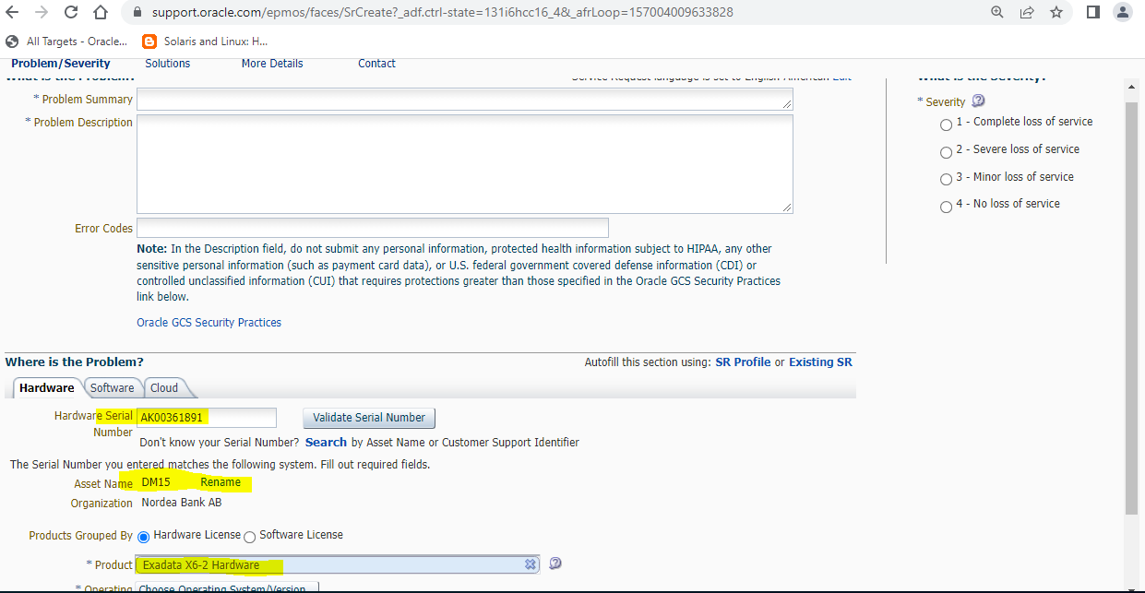

Login as root on Cell node and run TFA

# **tfactl diagcollect -from "Mar/17/2022 13:00:00" -to "Mar/17/2022 16:00:00"**

Once Oracle confirmed that the Disk need to replace and for that Oracle need datacenter location information and visit date/time.

* To find the DC address and Exadata machine device location. Please use below link .

<http://nlyte.oneadr.net/nlyte>

to get the access for this VDC portal :-

VDC-Datacenter [**Vdc-Datacenter@nordea.com**](mailto:Vdc-Datacenter@nordea.com)**,** team will provide this access, please share directly you G ID (username) and team will provide the same.

They will provide access on same day , no approval required for this.

Now once you login the portal then give the Exadata Machine serial number (given above) in search box.

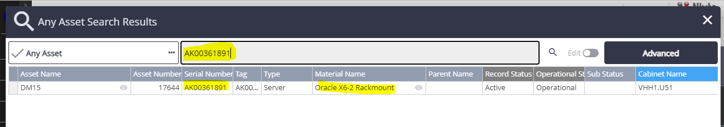

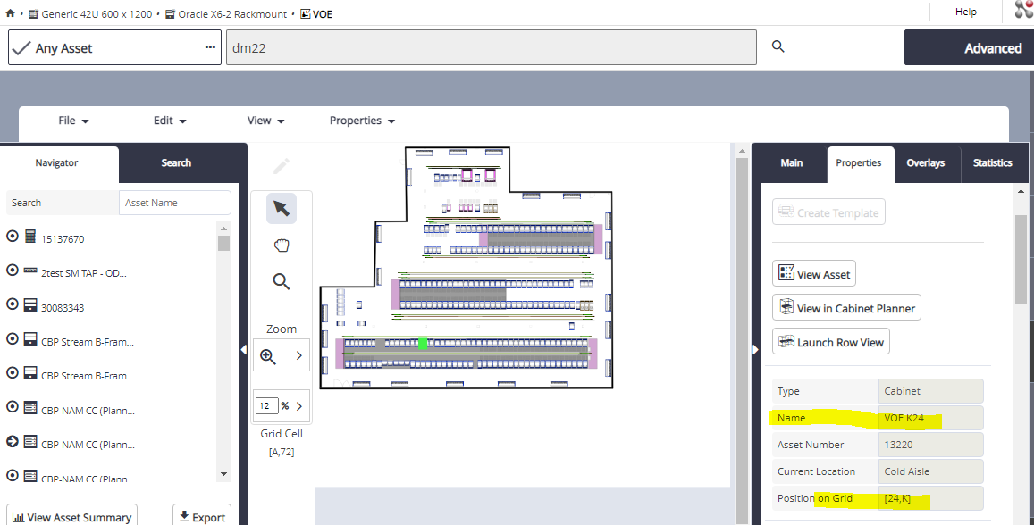

Now take the device location/ DC address from the <http://nlyte.oneadr.net/nlyte> and update below format .

* Update the Fiend engineer task in below format.

Note:- we have to create one INC for this as well for internal tracking and DC physical request.

|  |  |  |
| --- | --- | --- |
| **S No** | **Requirement** | Details |
| 1 | Problem description | Disk failed identified on 8:11 |
| 2 | Scope of Work | Disk Controller or Supercapacitor need to be replace |
| 3 | **Location Type, exp: HQ, DC, Branch, ATM or critical sites.** | **Data Center VHH , VHH1 - 4 - Area** |
| 4 | Date for On-site visit | Tuesday (29-March-2022) at 09:00 AM CET |
| 5 | **Site Address with postal code** | **VHH1 - 4 - Area (Copenhagen,Hermes Hus,0,VHH1)** |
| 6 | **Device location in Building** | **VHH1** |
| 7 | **Device Room & Rack Details** | **Room Name :- VHH1.U51,  Grid Ref :-  [51,U]** |
| 8 | Hostname & IP address | |  |  |  |  | | --- | --- | --- | --- | | |  |  | | --- | --- | | **dm22celadm01** | **10.104.230.85** | |  | |
| 9 | Device Serial number, Make & Model | Oracle Server X6-2, system_identifier=Exadata Database, Serial Number :-  AK00361891, component_serial_number = 1612NM10K4 |
| 10 | Required tools | no tools required |
| 11 | Original ticket number | SR 3-29042244811 : Disk replacement  Onsite FT task number :- 32315792   Helix INC number :- **INC000002843185** |
| 12 | Extra Details (If Any) |  |

Now, update the above information in Oracle SR and send mail notification for this issue with solution and progress.

* Field Engineer DC physical access request raise

We have to raise a physical DC access and to verify it should be approved/granted before visit.

<https://ioweb.oneadr.net/itssp/#shop>

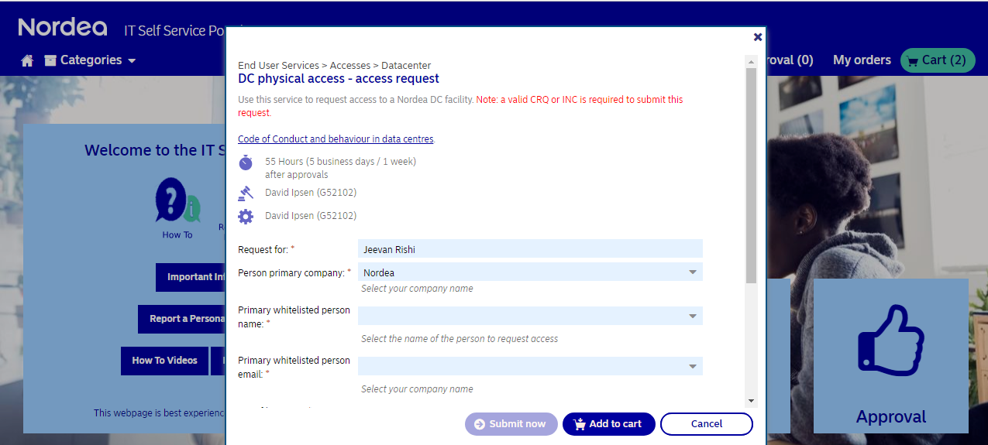

Update the details in this online form :-

Update the primary company “ Infocare DK” , whitelisted person name from drop down .

Select the location from dropdown “VOE or VHH” . entry reason “ helix INC” given the access start date/time and end date/time . and update Helix INC number and submit the request.

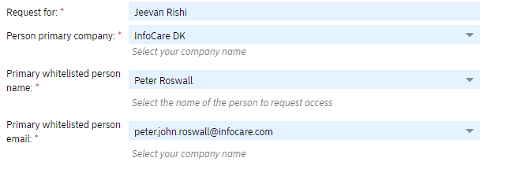

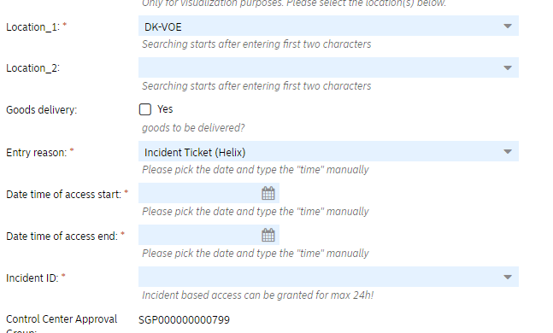

And after that in 30 min check the status of request and follow-up to get it approve.

* **Day of HHD replacement**

Turning on the Service Action Required LED on can be used to ensure work is done on the proper disk. Oracle recommends the LED be turned off after service.

The Service Action Required LED is turned off after the disk has been replaced or put back in the server.

The DROP FOR REPLACEMENT option checks if a physical disk can be removed safely, without the risk of data loss. If the disk can be dropped, then the command disables the physical disk, drops the disk, and turns on the service LED.

CellCLI> ALTER PHYSICALDISK 8:11 DROP FOR REPLACEMENT

CellCLI> list physicaldisk 8:11 detail

And once FE will replace the HHD then check the DISK status

CellCLI> list physicaldisk 8:11 detail

And check the rebalancing status :-

Sqlplus> select * from v$asm_operation;

**Note :-** do not replace another HHD disk in any of the cell node of the same Exadata machine until the previous rebalancing operation running. Once rebalancing operation completed the we are good to go to replacement for another disk.